**Al Imam Mohammad Ibn Saud Islamic University College of Computer and Information Sciences**

# Information Systems Department

**Course Title:** App Development

|  |  |
| --- | --- |
| **Course Code:** | IS337 |
| **Course Instructor:** | Dr Fareeha Anwar. |
| **Exam:** | Project |
| **Semester:** | 2nd 2024-25 |
| **Due Date:** | 4/2/2025 |
| **Duration:** |  |
| **Marks:** | 20 |

**Privileges:** ☐ Open Book ☐ Open Notes

☐ Calculator Permitted ☐ Laptop Permitted

|  |  |
| --- | --- |
| **Group Number:** | 4 |
| **Section Number:** | 372 |

|  |
| --- |
| **Instructions:**   1. Answer all requirements; there are **(8) requirements in (3) pages.** 2. Upload on the Blackboard a zip file of your assignment folder (report included). 3. *You are required to follow the rules of plagiarism (see last page)* |

|  |  |  |
| --- | --- | --- |
|  | **Official Use Only** | |
| **Question** | **Student Marks** | **Question Marks** |
| 1 |  | 20 |
|  |  |  |
|  |  |  |
|  |  |  |
|  |  |  |
| **Total** |  | **10** |

Table of Contents

Information Systems Department 1

Introduction: 3

Assignment Highlights: 3

Website Pages: 4

Join-us page: 4

Sign-in page (Book Ticket): 5

Feedbackpage: 7

About Us page: 10

Database tables: 11

Users table: 11

Feedback table: 12

Programming languages: 12

HTML: 12

CSS: 12

JavaScript: 12

PHP: 12

**Table of Figures**

Figure 1 Sabic Station webpage 3

Figure 2 Sabic Station Information Section 3

Figure 3 Sabic Station FAQs Section 3

Figure 4 Join Us page 4

Figure 5 form's action 4

Figure 6 Register code 4

Figure 7 Sign-in Page 5

Figure 8 After Sign-in 5

Figure 9 form's action 6

Figure 10 sign-in php code 7

Figure 11 Feedback page 8

Figure 12 Feedback php code 1/2 8

Figure 13 Feedback php code 2/2 9

Figure 14 About Us page 10

Figure 15 About Us CSS 10

Figure 16 About Us JavaScript 11

Figure 17 Users table 11

Figure 18 Feedback table 12

# Introduction:

This project “Student Public Commuter” is a continuation to the assignment, which was the first phase of the project, the project aims to develop a website that contains information about SABIC station to help student who want to use the metro to go to college. This is the second phase of the website which has additional features such as, the “about us” page and “Feedback” page and database connectivity. This report will be about showing the implementation, and the output of the additions and updates made to the previous website in the assignment, the report will also discuss and explain the steps taken to meet the requirements of the project.

# Assignment Highlights:

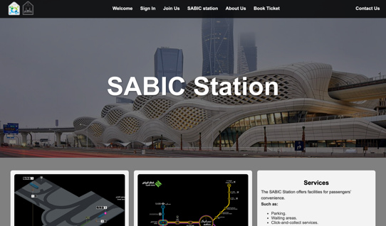

Figure Sabic Station webpage

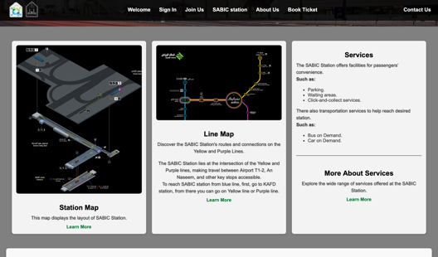

Figure Sabic Station Information Section

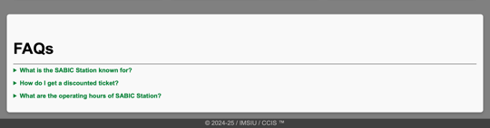

Figure Sabic Station FAQs Section

The SABIC Station is a dedicated page within the website that is accessible exclusively to registered and signed-in users. This page provides detailed information about the SABIC Station, including its services, station map, and frequently asked questions to enhance user experience. It highlights key station features, routes, and facilities, offering a user-friendly interface designed for easy navigation.

# 

# Website Pages:

## Join-us page:

We added a password text field to store the user’s information in the database, as a way of ensuring that the user is the same one who registered.

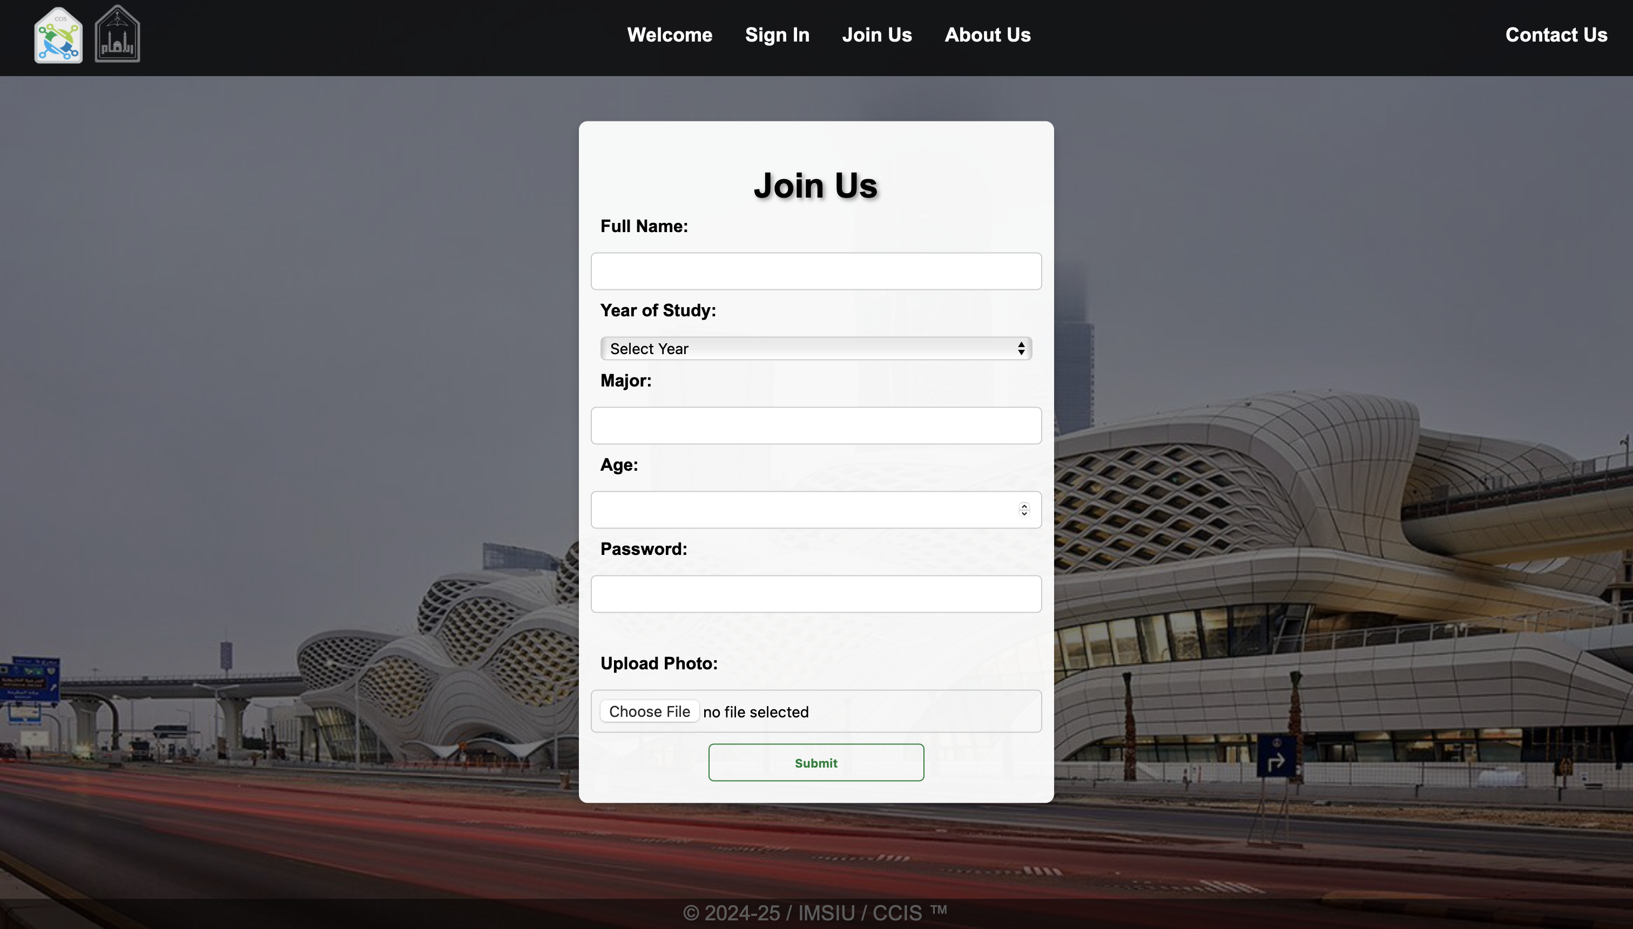

Figure Join Us page

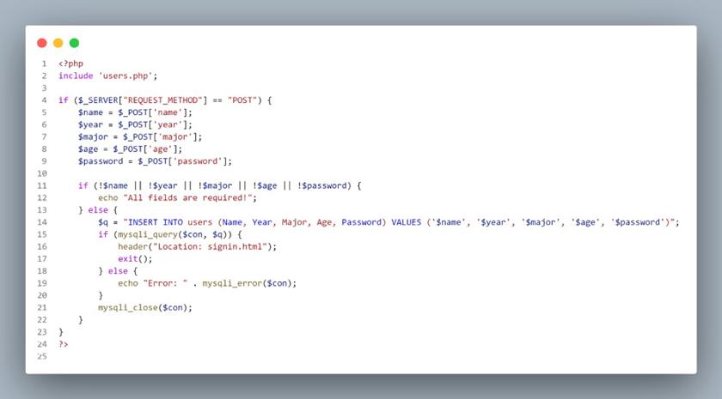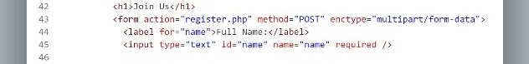The “register.php” was added to the form’s action.

Figure form's action

Figure Register code

## 

## Sign-in page (Book Ticket):

When users enter their registration information correctly and verify that they have registered their name and password accurately, they can sign in and book a ticket.

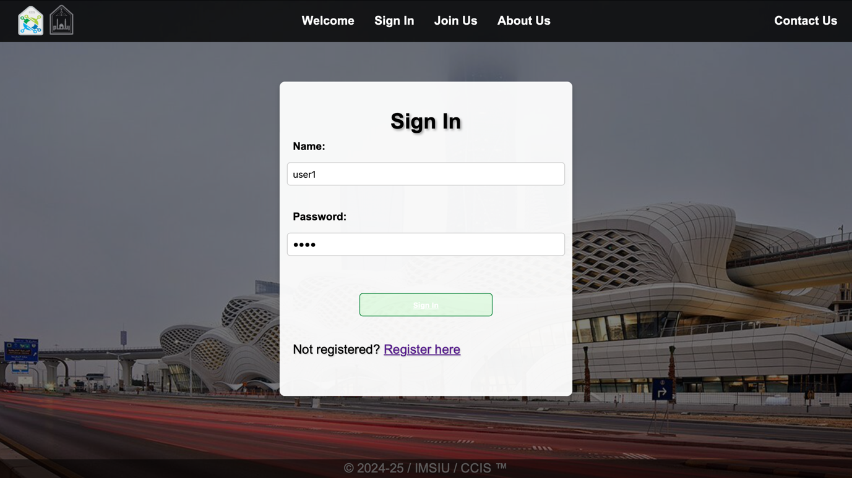

Figure Sign-in Page

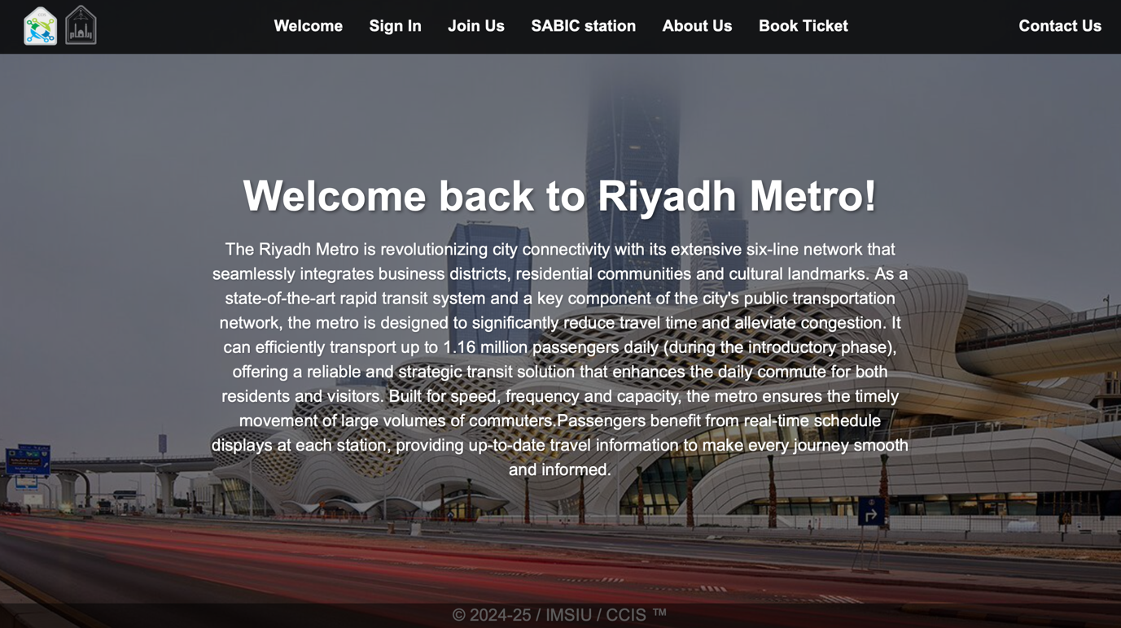

Figure After Sign-in

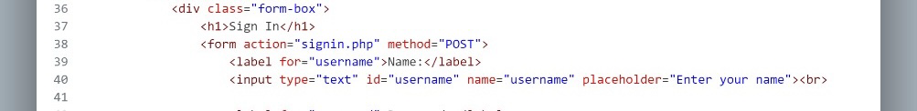

Figure form's action

## Adding the “signin.php” in the form’s action for connectivity. Shown in figure 9.

Figure sign-in php code

## Feedbackpage:

Our feedback page consists of the Feedback form that users fill in with their feedback, once feedback entered and submitted the php gets the submitted feedback from the form and the name of user from session and then store it in the database.

And shows the feedback with the user’s name in the “Feedbacks” section.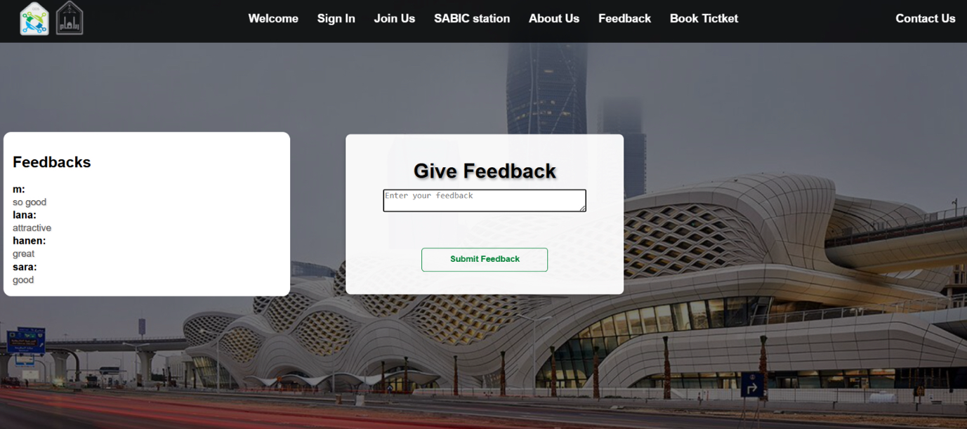

Figure Feedback page

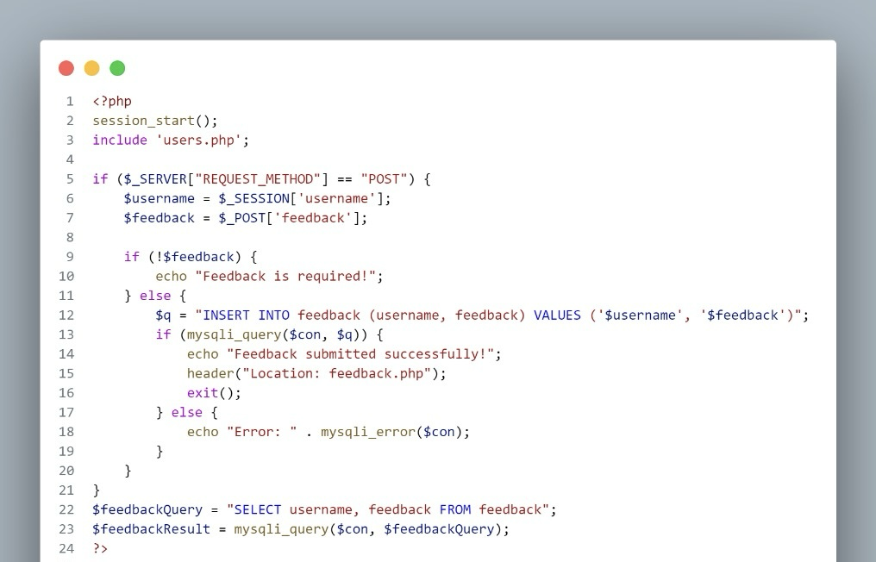

Figure Feedback php code 1/2

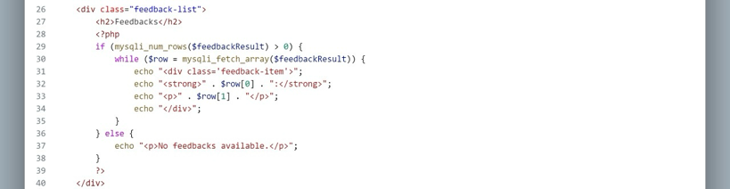

Figure Feedback php code 2/2

## 

## About Us page:

The About Us page consists of information about the website developers, presented in a slideshow. The black background was a design choice, to make the page look more professional.

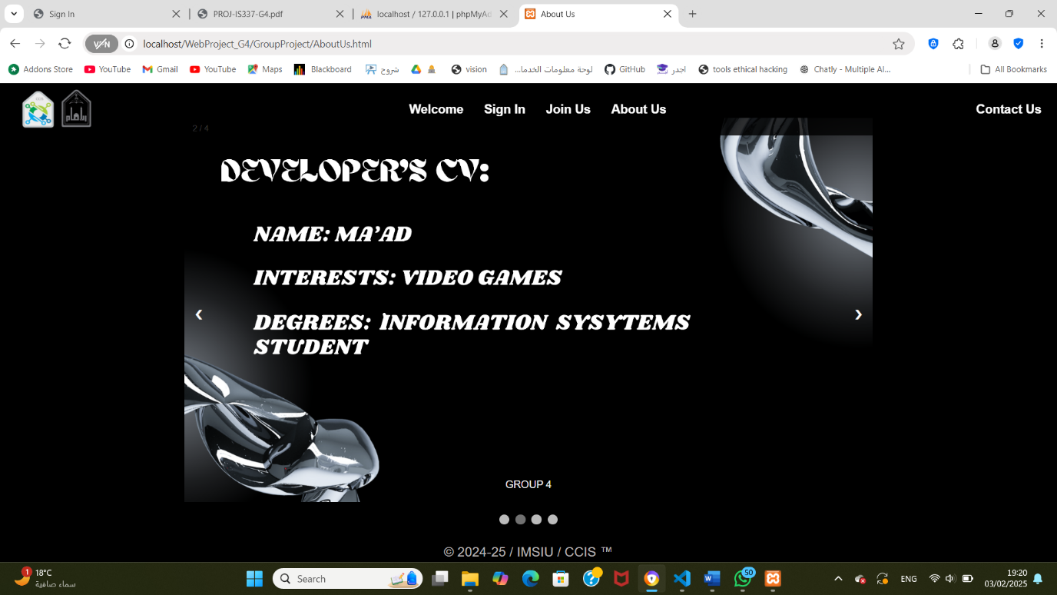

Figure About Us pa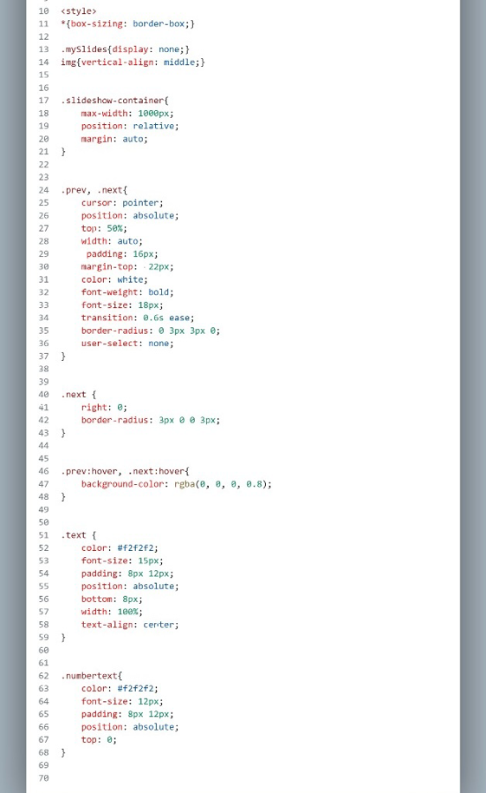ge

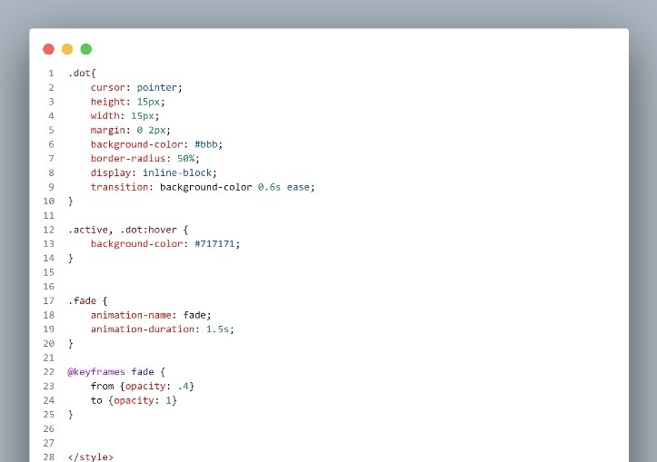

Figure About Us CSS

An additional CSS code had to be implemented for the slideshow. Shown in figure 15.

Also, a JavaScript code had to be implemented as well. Shown in figure 16.

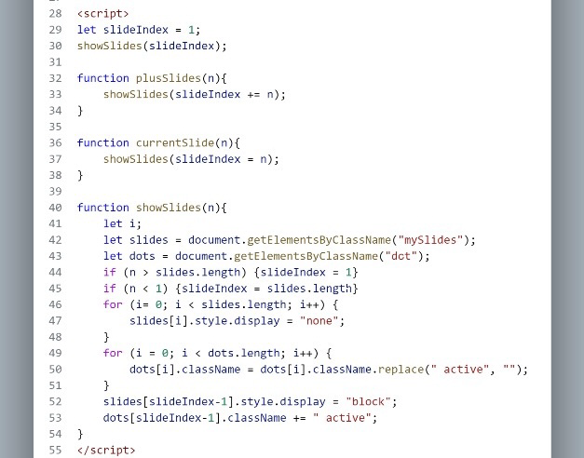

Figure About Us JavaScript

# Database tables:

## Users table:

Display the registration information, and the sign-in page verifies if users have entered their name and password correctly, allowing them to sign in.

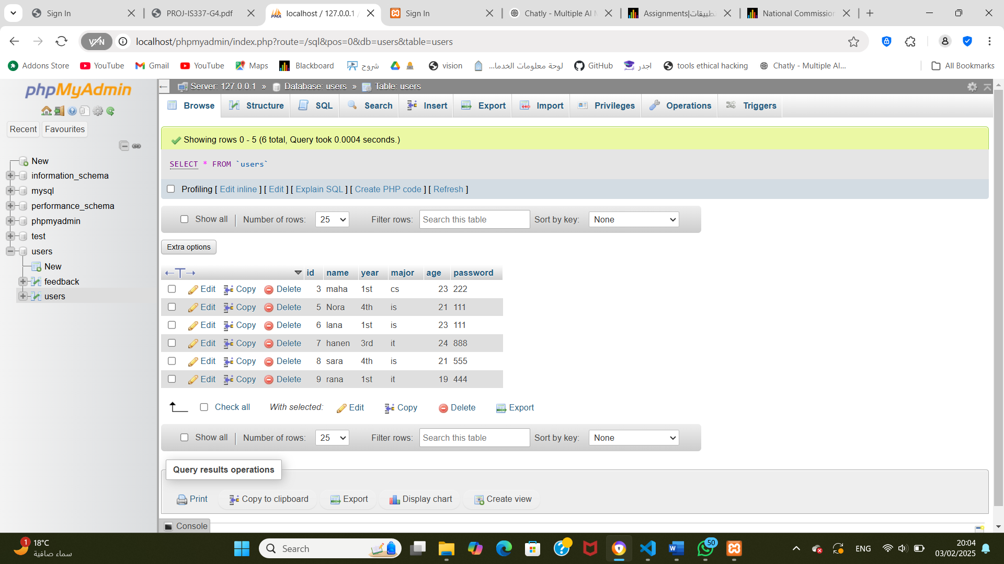

Figure Users table

## Feedback table:

Display the feedback submitted by users in the form, along with the name of the user from the session and then store it in the database.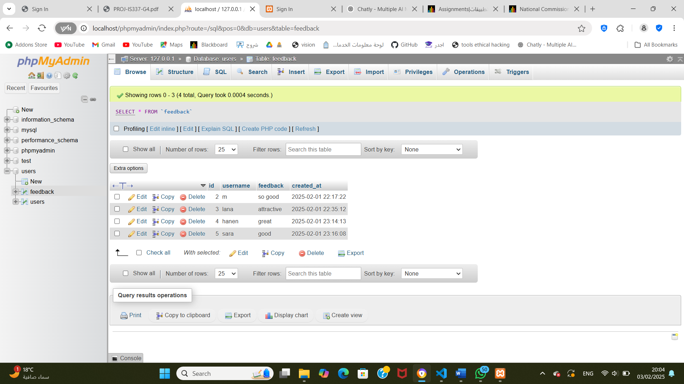

Figure Feedback table

# Programming languages:

## HTML:

HTML was used to program and develop all pages.

## CSS:

We implemented CSS to create a consistence style throughout the website. We decided to use an external stylesheet due to its convenience for reuse and modification.

## JavaScript:

A JavaScript code was implemented in the About Us page for slideshow. Shown in figure 16.

## PHP:

We verified the user’s singing in information, when feedback is submitted, the PHP retrieves the feedback from the form and the user's name from the session, then stores this information in the database.

**Group members’ duties:**

|  |  |  |  |  |
| --- | --- | --- | --- | --- |
| **Student #** | **Student Name** | **Student ID** | **Responsibilities** | **Signature** |
| **1** | **Sarah bin Abdulqader** | **444005968** | **1- sign-in php.**  **2- Feedback php.**  **3-Database.**  **4-Book ticket in the navigation bar when singing in.** |  |
| **2** | **Nora Alsalem** | **444007071** | 1. **Sign in.** 2. **Database.** |  |
| **3** | **Ma’ad Benrawwaf** | **443011233** | 1. **About us page** 2. **Slideshow in About Us page** 3. **Website improvements.** 4. **Register php** |  |